NTA TELEVISION COLLEGE, JOS
AHMADU BELLO UNIVERSITY, ZARIA

GUIDELINES ON PAYMENT OF FEES AND COURSE REGISTRATION ON THE NEW PORTAL

Please follow these steps to register in the NTA TV College portal
Step1: The Student portal URL is http://student.ntatvc.edu.ng.
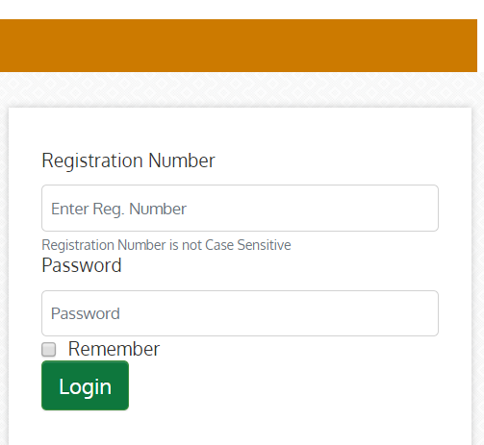
Enter Student Registration Number and a Password (123456 as default, if not yet changed), then click on the button “Login”
After successful login, an authorized student would be taken to his dashboard as shown below
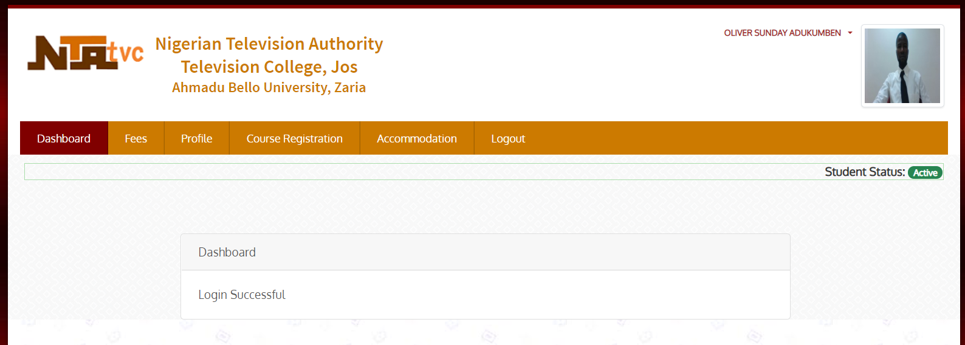
The menus are: Dashboard, Fees, Profile, Course Registration, Accommodation and Logout.

Step 2: You must supply all the required information under Profile menu before you proceed to pay school fees.
NB: Ensure you supply correctly, all relevant information as failure to do so may hinder smooth usage of the portal.
Again, you are expected to change your password to something else that you cannot forget
Step 3: For school fees payment click on the menu “Fees”
When clicked, the history of the logged in student payments’ history is displayed.
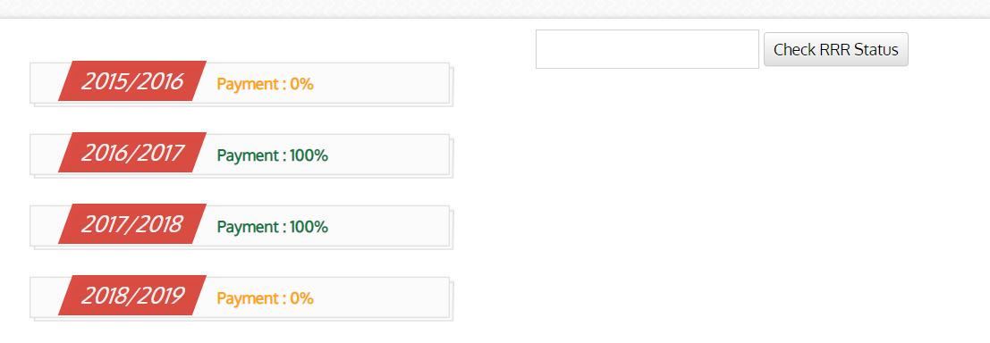
Step 4: Click on the appropriate session to be paid for. Example, 2018/2019, then you will be navigated to a page where you have an option of making 100% or 50% of the scheduled payment, as shown below:
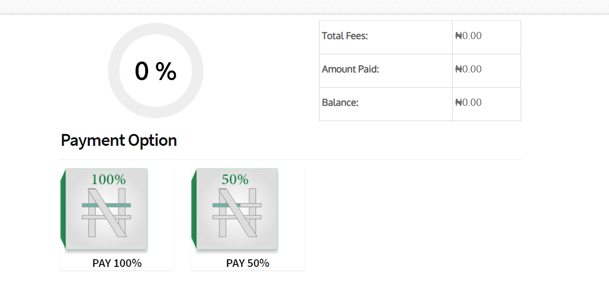
Step 5: Clicking any of the two options take you to the payment details with a payment link that will link the payer to his/her preferred payment method (Remita or Bank collect). The payment detail is shown below:
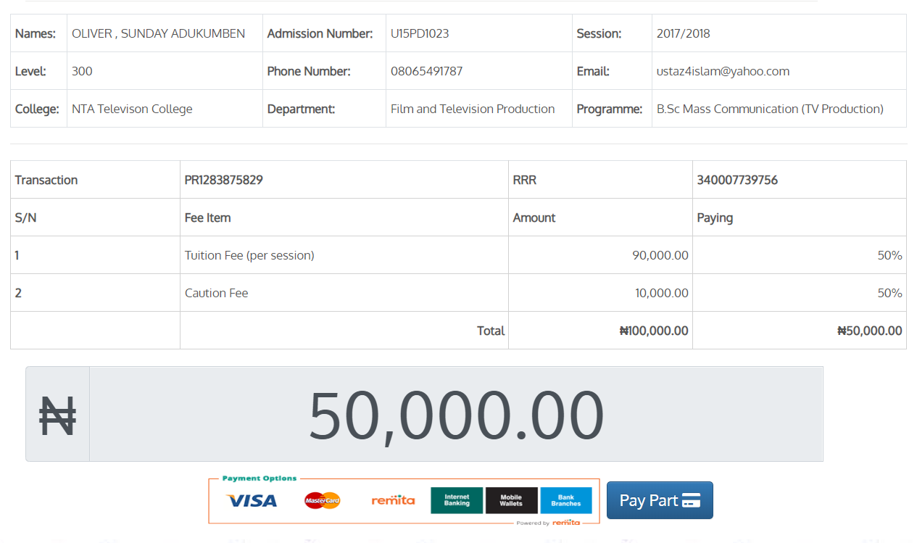
Step 6: On successful payment, you can now click on Course Registration to register your courses for the first and second semester. Note that the registration period is set in this portal, failure to register within the stipulated time, you may have to seek for administrative approval.

